# Report 5

**team members：**

白明松 16301059

**technical features applied：**

Use Case Scenario:

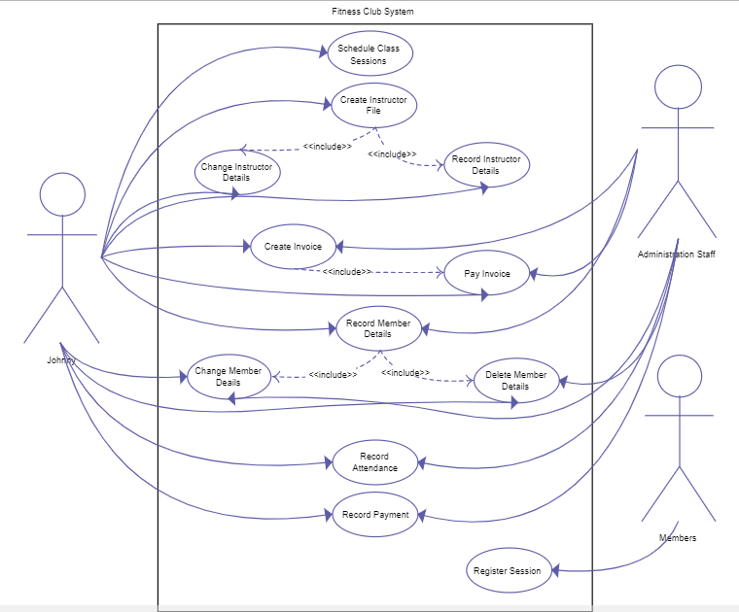

As per requirements from our client, users hope the app will enable them to login to the gymclub app with their social account in QQ, Wechat, Facebook and etc.

